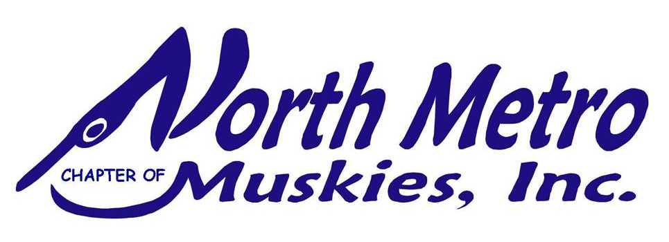
NMMI Website | NMMI | NMMI League Night
_________________________________________________________

“Catch the Cousin” VIRTUAL Northern Pike
Ice Fishing Contest
A Conservation Project hosted by the North Metro Chapter of Muskie’s Inc.
*NMMI Members-Only*
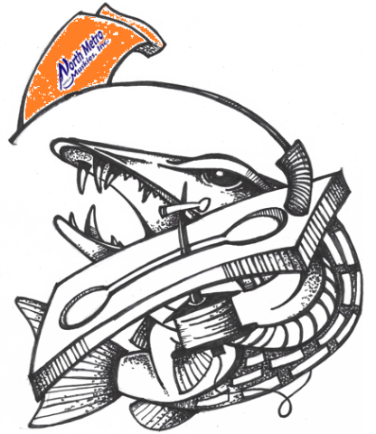
Photo Credit 1Ted Mitshulis
December 9th, 2022 – February 26th, 2023

Welcome to the 2023 Third Annual “Catch the Cousin” Conservation Contest, brought to you by the North Metro Chapter of Muskie’s Inc. (Chapter 21)! To keep the party going all year long, we are hosting this contest to highlight a muskie relative – the Northern Pike – and to emphasize the importance of fisheries conservation. Let’s go!
RULES
Even though these relatives look similar and are of the toothy Esox variety, catching Minnesota’s Northern Pikes during the ice fishing season is a whole new ball game. In addition, it is just as important to help preserve and protect our fisheries in the winter as it is during open water season. This is an “on your honor” tournament, so please report your fishing results accurately. We encourage all participants to follow all COVID-19 safety protocols, but we hope you can make this a family affair! Bring your kids, dogs, and grills and enjoy some fresh air out on the ice.

HOW MUCH DOES IT COST?
This virtual tournament is a members-only tournament and is 100% FREE to all NMMI members, including youth participants. You’ve got nothing to lose and every reason to join in the fun!

WHERE AND WHEN CAN I FISH?
This contest will run from December 9, 2022 – February 26, 2022. All fish must be reported by 11:59 PM on February 26, 2022. You can fish in any lake, river, pond, stream, or ditch in Minnesota, North Dakota, South Dakota, Iowa, and Wisconsin. Unfortunately, Canada is purposefully not included in this list.

MEDIA RELEASE
By participating and submitting photos, you are granting NMMI the right to use photographs, video, and information concerning your participation in the tournament for any internal or external third-party media for the North Metro Chapter of Muskie’s Inc.

HOW DO I GET POINTS?
While this contest is all about finding ways to catch Northern Pike, there is also an equal emphasis on finding ways to preserve and protect our beautiful Minnesota fisheries. If you are spearing, we highly encourage you NOT to spear any trophy pike. Please take a photo of your fish and/or ice clean-up and submit photos. We highly encourage submitting photos, but they are not required in order to participate. However, because this is an educational awareness and conservation tournament, we would be most grateful for any and all photo submissions.

Category | Points
Northern Pike | Less than 22” | 1 Points
 | 22” – 26” | 2 Points
 | 27” – 39” | 3 Points
 | 40”+ | 5 Points
Ice Clean-Up Conservation  *Tournament Director has the discretion to issue more entries based on volume of trash collected. | *1 Entry Per Day into the Raffle Drawing for the Conservation Raffle Prize
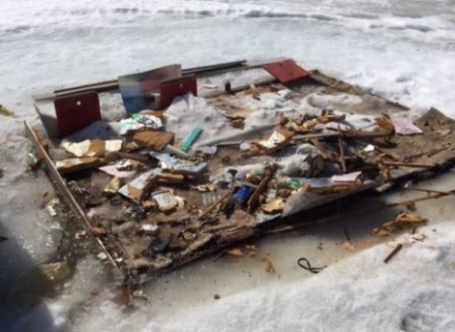
Ice Clean-Up Conservation Category
We all know that there are irresponsible anglers who leave plenty of trash behind on the ice. However, if you stop to grab some of this trash and do your part to conserve our beautiful waters, you will be awarded entries into the Ice Clean-Up Conservation Bonus Raffle. Only one entry per trash haul for the raffle, but the Tournament Director does have the discretion to issue more entries based on the volume of trash collected. Please make sure to take pictures of your haul to earn entries!
Photo Credit 2 MN DNR
*Extra Credit: If you want to get really creative with your conservation efforts, consider magnet fishing and see what you can pull up.

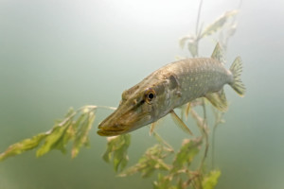
Hammer-Handle Harvest Encouraged!
The Minnesota DNR recently rolled out the state’s Northern Pike Zones, and the largest North Central Zone is plagued with far too many small pike. This overabundance of small pike is problematic, so we encourage all participants to consider harvesting those small fish rather than throwing them back. Please feel free to post any harvest pictures and share how you like to cook and eat your delicious little hammer-handles. [How to Fillet Northern Pike]

REPORTING YOUR POINTS
Photo Credit 3 MN DNR
To record your points and get on the board, please report your photos and measurements to NMMI Board Member and Tournament Director Nikki Bentley, and feel free to share your photos on the NMMI Facebook page. Photos are required as you simply can’t say, “I caught a pike and picked up some trash.”
- Facebook Messenger to Tournament Director, Nikki Bentley
- Text Nikki: 701-261-2894
- Email: thenikkibentley@gmail.com

Results will be continuously tabulated and shared periodically via our website, social media, and our NMMI membership newsletters.

PRIZES
While fishing and protecting our fisheries may be in your DNA, we are also offering some external motivation and competition to the members who fish hard and are trash-picking machines:
- Northern Pike Champion – Thorne Bros. Gift Card
- Ice Clean-Up Conservation Champion – Thorne Bros. Gift Card

GOOD LUCK!

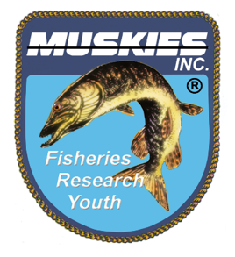
Muskies, Inc. is an Active, Service-Oriented, 501(c)(3) Non-Profit Organization for men, women, and children. Founded in 1966 by Gil Hamm, the original group of thirteen avid Muskie fisherman concentrated on continual improvement of the Muskie resource through rearing and stocking efforts and sound conservation practices.

